**INTERNAL TRANSPORT DIGESTION, ENZYMES and EXCRETION**

**Question 1**

Which of the following correctly identifies the digestive enzyme with its substrate and products?

|  |  |  |  |  |
| --- | --- | --- | --- | --- |
|  | **Enzyme** | **Location** | **Substrate** | **Product** |
| a. | Amylase | Oesophagus | Starch | Disaccharides |
| b. | Pepsin | Small intestine | Polypeptides | Peptides |
| c. | Lipase | Stomach | Lipids | Fatty acids + glycerol |
| d. | Peptidases | Small intestine | Polypeptides | Peptides |

**Question 2**

Which of the following describes the direction of blood flow through the kidney?

1. Renal artery, afferent arteriole, efferent arteriole, peritubular capillaries, renal vein.
2. Renal vein, afferent arteriole, efferent arteriole, peritubular capillaries, renal artery.
3. Renal artery, efferent arteriole, afferent arteriole, peritubular capillaries, renal vein.
4. Renal artery, peritubular capillaries, afferent arteriole, efferent arteriole, renal vein.

**Question 3**

Structures called villi are found on the surface of the small intestine. Which of the following statements about intestinal villi is INCORRECT?

1. They provide a high surface area for nutrient absorption.
2. They contain specialised blood capillaries known as lacteals.
3. The cells on their surface are covered with tiny folds called microvilli.
4. They are about 1mm in length.

**Question 4**

Lacteals absorb

1. fats.
2. peptides.
3. carbohydrates.
4. glucose.

**Question 5**

A decrease in secretions from the gallbladder would cause

1. an increase in gastric secretions.
2. an increase in peristalsis.
3. a decrease in water absorption.
4. a decrease in the concentration of glycerol in the small intestine.

**Question 6**

Which of the following substances would you reasonably expected to find in a person’s stomach after a meal?

1. Water, salts, maltase and bile.
2. Starch, glycerol, pancreatic amylase and trypsin.
3. Protein, pepsin, hydrochloric acid and maltose.
4. Hydrochloric acid, peptides, bicarbonate ions and bile.

**Question 7**

Which one of the following occurs in the digestive system?

* 1. Food moves through the oesophagus by diffusion.
  2. Digestion of starch occurs in the stomach.
  3. Absorption of digested material occurs in the small intestine.
  4. Digestion of fats occurs in the large intestine.

**Question 8**

Which enzyme functions optimally in a low pH?

* 1. Intestinal lipase.
  2. Gastric protease.
  3. Pancreatic protease.
  4. Salivary amylase.

**Question 9**

The pancreas secretes the following substances **EXCEPT**

* 1. Hydrogen carbonate ions.
  2. proteases.
  3. lipase.
  4. cholesterol salts.

*Use the following graph to answer question 10.*

**Question 10**

The above data was collected using small intestine enzymes and disaccharides. Which of the following would best describe the amount of product that would be formed at each temperature if the same experiment were repeated at pH of 4?

* 1. The amount of product would be the same.
  2. The amount of product would be greater.
  3. The amount of product would be less.
  4. The amount of product cannot be determined due to insufficient information.

**Question 11**

‘Nutra Sweet’ is used to sweeten (diet) drinks instead of sucrose. Nutra Sweet is composed of two (2) amino acids. The chemical element present in Nutra Sweet that would not be present in sucrose is

1. nitrogen.
2. oxygen.
3. hydrogen.
4. carbon.

**Question 12**

Salivary amylase ceases to function when food is swallowed because it is

* 1. inactivated at a low pH.
  2. broken down as starch is digested.
  3. inactivated at a high pH.
  4. unable to function in the higher temperature found in the stomach .

**Question 13**

Individuals who have had their gall bladder removed should

* 1. eat smaller amounts of carbohydrate.
  2. eat smaller amounts of protein.
  3. eat smaller amounts of lipids.
  4. not make any dietary changes.

*Use the following table to answer the question which follows.*

**Multi-Vitamin Tablet analysis**

|  |  |
| --- | --- |
| Niacin | 17% |
| Vitamin B6 | 5% |
| Vitamin B1 | 4% |
| Vitamin C | 50% |
| Calcium | 17% |
| Iron | 3% |
| Magnesium | 4% |

**Question 14**

What is the total mass of minerals (in milligrams) present in a tablet weighing 0.5 grams?

* 1. 0.12mg
  2. 1.2mg
  3. 12mg
  4. 120mg

**Question 15**

Calcium is required in the diet to allow the normal development of the

1. skeleton.
2. lungs.
3. eyes.
4. skin.

*Use the following graphs to answer the question below*.

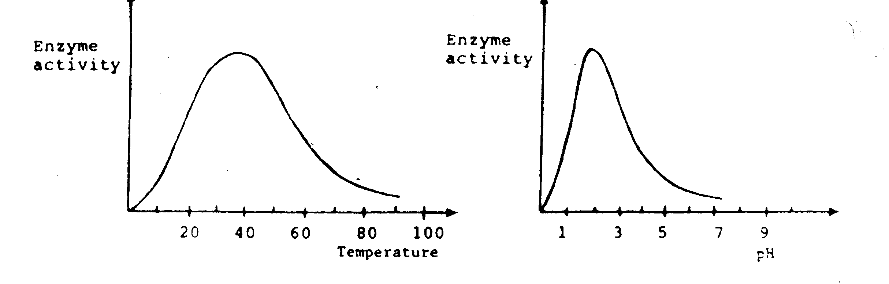

**Question 16**

From the graphs you would conclude that the enzyme has maximum activity at

* 1. pH 2 and temperature of 35oC.
  2. pH 2 and temperature of 50oC.
  3. pH 3 and temperature of 50oC.
  4. pH 3 and temperature of 35oC.

**Question 17**

The diagram below refers to parts (a) to (c) of Question 17.



1. Which structure produces a substance that aids in the physical digestion of food?

__________________________________________________________________ (1)

1. Name the following two structures:

**W**______________________ (1)

**Z**_______________________ (1)

1. Describe **THREE** different ways that **Z** facilitates digestion. (3)

(i) ____________________________________________________________________________________________________________________________________________

(ii) ____________________________________________________________________________________________________________________________________________

(iii)

____________________________________________________________________________________________________________________________________________

**Question 18**

Enzymes are responsible for controlling the chemical reactions that occur in the cells of any organism. In trying to understand the way that enzymes function, a cellular biologist carried out an investigation into what factors affect enzyme action. She measured the time it took for an enzyme to break down a substance (substrate) at different temperatures. During the experiment she kept the pH of the solution constant. Her results are shown in the graph below. At temperatures greater than 50oC the enzyme was unable to breakdown the substrate.

(a) At what temperature is the time taken to breakdown the substrate at a minimum?

(1)

(b) Explain the significance of this minimum time in terms of enzyme activity.

(2)

(c) Explain why the time taken to break down the substrate increases after 40oC.

(2)

(d) In a second similar experiment, the biologist decided to investigate the effect that pH would have on the effectiveness of the same enzymes. Briefly outline how she would carry out the experiment.

(3)

(e) On the axes below, sketch in a graph that would represent the data collected by the biologist in her second experiment. Also label the axes. (2)

**Question 19**

Some individuals suffer a condition called heartburn or gastric reflux. This is characterised by a burning sensation occurring in the chest. It is sometimes accompanied by a bitter or sour taste in the mouth due to the acidic stomach contents *refluxing* upwards.

(a) Why is acid found in the stomach?

______________________________________________________________________________________________________________________________________________ (2)

(b) Do any other digestive organs secrete acidic fluids?

_______________________________________________________________________ (1)

(c) One cause of gastric reflux is a weakened valve between the oesophagus and stomach.

1. What is the name of this valve? __________________________________________________ (1)

(ii) What is the valve’s function in the digestive tract and name the valve that leads from the stomach to the duodenum? (2) ____________________________________________________________________________________________________________________________________________

(d) One treatment for gastric reflux is the use of antacid.

(i) What effect does this substance have in the stomach? (1)

__________________________________________________________________________________________________________________________________________________

(ii) Will the pH of the stomach increase or decrease after the use of an antacid? Explain.

________________________________________________________________________________________________________________________________________________________________________________________________________________________ (2)

**Question 20**

Diagram of the digestive system and urinary system.





1. Indicate ALL part(s) of the diagrams above responsible for carrying out the following processes. (10 marks)

|  |  |
| --- | --- |
| Process | Responsible Structure(s) |
| i. Produces the enzymes that digest starch |  |
| ii. Involved in mechanical digestion |  |
| iii. Produces substance to neutralise stomach acid |  |
| iv. Grinds food |  |
| v. Involved in chemical digestion |  |
| vi. Trypsin is produced here |  |
| vii. Urine is stored here |  |
| viii. The glomerulus is located here |  |
| ix. Ammonia is produced in this organ |  |
| x. A component of the lymphatic system is located in this region |  |

**Question 21**

The nephron diagram below refers to the following three questions.

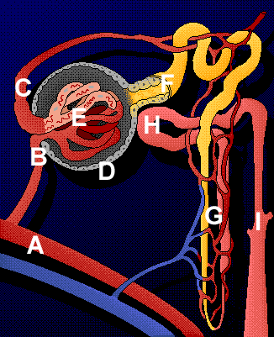

1. Identify the labelled structures of the nephron. (3)

**D** ____________________________________

**E** ____________________________________

**I** ____________________________________

1. Blood enters the nephron at **B** and any unfiltered substances exit at **C**.

List **TWO** substances found at **C**. (2)

__________________________________________________________________________________________________________________________________________________

(c) (i) What is structure **H**? _________________________ (1)

(ii) Describe the process that occurs at structure **H** and how this affects the composition of urine.

_________________________________________________________________________

_________________________________________________________________________

_________________________________________________________________________

_________________________________________________________________________

_________________________________________________________________________

_________________________________________________________________________

(3)

**Question 22**

1. Discuss the role of the various regions of the nephron in regulating body fluid. Use data from the table below to support your answer. (14)

### Concentration of Solutes (micrograms / Litre)

|  |  |  |  |  |  |
| --- | --- | --- | --- | --- | --- |
| Solute | Glomerulus | Bowman’s Capsule | Proximal Convoluted Tubule | Distal Convoluted Tubule | Collecting Duct |
| Protein | 5,000 | 5 | 0.3 | 0 | 0 |
| Glucose | 230 | 230 | 19 | 0 | 0 |
| Urea | 55 | 55 | 50 | 60 | 100 |
| Sodium Ion | 440 | 440 | 50 | 75 | 80 |
| Chloride Ion | 700 | 700 | 70 | 30 | 60 |

**Question 23**

1. What are enzymes? Enzymatic digestion occurs in the mouth, stomach and small intestine. Name the enzymes, the particular carbohydrates and lipids digested and give the products that result from this enzyme action in the parts of the alimentary canal mentioned. (10)